Task 2.6: Add static files

Resources:

* [Static Files & Images | Django Framework (3.0) Crash Course Tutorials (pt 4)](https://www.youtube.com/watch?v=kqyfEz7TNI0&list=PL-51WBLyFTg2vW-_6XBoUpE7vpmoR3ztO&index=4)
* [os.path — Common pathname manipulations — Python 3.11.5 documentation](https://docs.python.org/3/library/os.path.html)

1. Create a new folder in the portfolio folder named “static” and create a folder inside of static named “images”

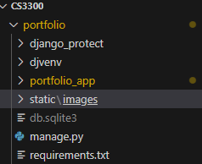

1. Download the UCCS logo from this link: <https://brand.uccs.edu/sites/g/files/kjihxj1416/files/inline-images/uccs-signature-email.gif>
2. Rename the logo to “uccs_logo.png”
3. place it into the images folder



3) Update the settings.py file inside the django_project folder

1. At the top (above “from pathlib import path) add “import os”

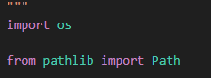

1. Near the bottom, under “#static files (CSS, JS, Images), add the following code:

STATIC_URL = ‘static/’

STATICFILES_DIRS = [

os.path.join(BASE_DIR, ‘static’)

]

MEDIA_URL = ‘/images/’

4) At this point the process may differ from person to person depending on a few things, all paths are covered below:

Go to base_template.html and look at the very top of the document, if there is a {% load static %} already above <!DOCTYPE html> then you can skip the following steps

If the {% load static %} is not there:

1. Add {% load static %} above <!DOCTYPE html>
2. Search for the <a class=”navbar-brand” href=”#”>Navbar</a> and replace it with <img src=”{%static ‘images/uccs_logo.png’ %}”>

5) check the website to make sure all the code worked by heading to 127.0.0.1:8000 and seeing if the logo appears, if not make sure the image is named “uccs_logo.png” in *every* instance it appears.

6) congrats! You’re done! Push it to the branch and merge once version is documented!